“Online Event Hall Booking Management System”

**Software Requirements Specification**

Version 1.0



Group Id: S2002687F7

Supervisor Name: Khaqan Khawer

Revision History

|  |  |  |  |
| --- | --- | --- | --- |
| Date (dd/mm/yyyy) | Version | Description | Author |
| 15/05/2020 | 1.0 | We are going to develop a web application named as “Online Event Hall Booking Management System”. The purpose of this application is to provide a online hall booking system. This application will provide an efficient system to hall managers add customers. Hall managers can add their hall details in system and customers can search for a hall and book any number of slots online. | BC170402435 |
|  |  |  |  |
|  |  |  |  |
|  |  |  |  |

Table of Contents

1. Scope (of the project)
2. Functional Requirements Non-Functional requirements
3. Use Case Diagram
4. Usage Scenarios
5. Adopted Methodology
6. Work Plan (Use MS Project to create Schedule/Work Plan)

**SRS Document**

**Scope of Project:**

Software scope describes the data and control to be processed, function, performance, constraints, interfaces, and reliability. Determination of the software scope is a pre-requisite of all sorts of estimates, including, resources, time, and budget. In order to understand the scope, a meeting with the client should be arranged. The scope of the project we are going to develop is below.

“The scope of the project is to minimize hunger and poverty in society by raising funds from different organizations and people. These organizations take donations for this purpose and arrange fund raising events so that everyone can donate anything. This project will build an efficient management system for such organizations to manage their resources and donations.”

**Range of the scope:**

* It has a registration process to register first.
* Three user types
  + Admin(pre-registered (one system admin))
  + Hall managers
  + customers
* It will allow only registered users to.
  + Approve hall (admin user)
  + To add hall details (hall manager users)
  + Book a slot (online customers)
* Admin can
  + Approve/disapprove new/existing hall managers
  + View customers profile
  + View all event hall bookings in system
* Hall managers can
  + Login/register to system
  + Add hall detail (hall need to be approved by admin before it goes live on system)
  + Edit hall detail
  + Add hall timing, food menu, extra features of hall like sound system etc.
* Customers can
  + Login/register to system
  + Search for a hall by location, event type etc.
  + Book a hall request
  + Give feedback on basis of 5 stars.

**Limitation of the scope:**

* Human/computer errors.
* Errors during registration and login.
* Duplicate records should be removed and the system should give message that the record is existing already.
  + like users (customers/hall managers) can create account with unique email only(duplicate email is not allowed).

**Functional Requirements:**

“Functional requirements view by system perspective. These requirements may be calculations, technical details, data manipulation and processing and other specific functionality that define what a system is supposed to accomplish”.

We are going to build up web application and the functional requirements are given below.

* There will be an admin user in app.
* User can’t register himself/herself as a admin user.
* The system should have user registration process for two perspective
* For those who want to add hall (hall managers).
* For those who want to book hall (customers).
* The user can add their hall details (hall needs to be approved by admin).
* The user can search for a hall by location, event type etc.
* The user can book a hall.
* The user can give feedback on basis of 5 stars.
* Admin can view customers profile.
* Admin can view hall details.
* Admin can approve/disapprove hall.
* Admin can see all bookings made in system.

**Non-Functional Requirements:**

“Non-functional requirement also called quality requirements. These requirements

Specify criteria that can be used to identify the operation of a system, rather than specific behaviors”.

The non-functional requirements are given below:

* **Usability:**

This application used by every user not for specific user.

* **Reliability:**

Reliability means how much this system would be reliable. The system needs to support 24/7 operation.

* **Performance:**

Authorization should be completed quickly in time.

* **Portability:**

The system should run on all the operating systems.

* **Access:**

System should be accessible for all the users.

**Use Case Diagram:**

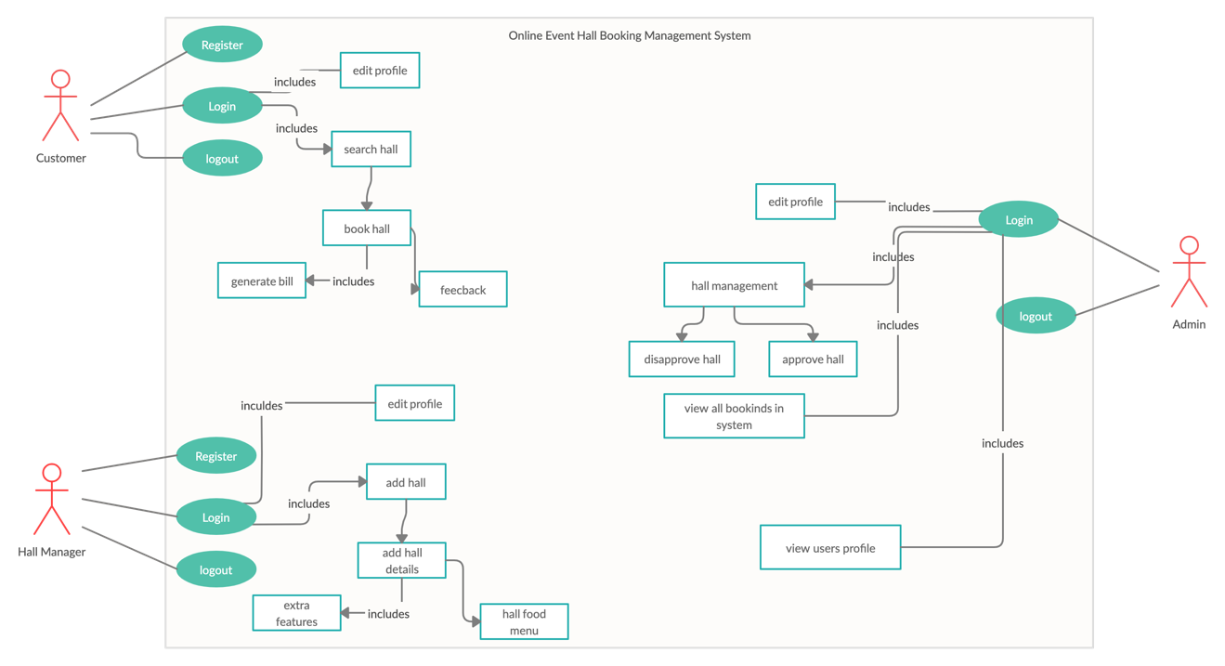

**Usage Scenarios:**

|  |  |
| --- | --- |
| Use Case title | **Registration** |
| Use Case Id | 1 |
| Actions | Open a registration form. |
| Description | Filling the registration form. |
| Alternative paths | No alternative paths. |
| Pre –Conditions | No pre-conditions. |
| Post-Conditions | After registration users are allowed to login. |
| Author | S2002687F7 |
| Exceptions | Server connectivity problems. |

|  |  |
| --- | --- |
| Use Case title | **Login** |
| Use Case Id | 2 |
| Actions | * User can login to its account * System will check the email and password |
| Description | User can login to its account to   * Add hall details (hall managers) * Search and book a hall (customers) |
| Alternative paths | Without login there is no alternative paths. |
| Pre and post Conditions | The user information was previously saved to the system and the system will check. After matching user info system allow the user to donate. |
| Author | S2002687F7 |
| Exceptions | Server connectivity problem, system problem. |

|  |  |
| --- | --- |
| Use Case title | **Logout** |
| Use Case Id | 3 |
| Action | User can logout from its account. |
| Description | User can logout from its account if he/she is done using website. |
| Alternative paths | User can also close the website. |
| Pre and post Conditions | **Before logout** user can make   * Approve/disapprove a hall (admin) * Add/edit hall details (hall managers) * Book a new hall (customers)   **After logout** user can login again. |
| Author | S2002687F7 |
| Exceptions | Server connectivity problem, system problem. |

|  |  |
| --- | --- |
| Use Case title | **Add/edit hall details** |
| Use Case Id | 4 |
| Action | User (Hall manager) will add/edit hall details |
| Description | Hall manager users can add/edit their hall details in system. |
| Alternative paths | Without adding hall there is no other path. |
| Pre and post Conditions | Before adding/editing hall details hall manager can add/edit his profile details.  After adding/editing hall details hall manager can logout. |
| Author | S2002687F7 |
| Exceptions | Server connectivity problems. |

|  |  |
| --- | --- |
| Use case title | **Search hall** |
| Use case id | 5 |
| Action | User(customers) can search a hall online. |
| Description | User(customers) can search a hall online using location, event type etc. |
| Alternative Paths | User can only search a hall from search page no other path. |
| Pre and post condition | Before search a hall user can edit his profile.  After search a hall user can book that hall or logout. |
| Author | S2002687F7 |
| Exceptions | Server connectivity problems. |

|  |  |
| --- | --- |
| Use Case title | **Book hall** |
| Use Case Id | 6 |
| Action | User can book a hall. |
| Description | User can book a hall by providing required details, and bill will generate on basis of provided details. |
| Alternative paths | To book a hall user need to provide required details, no alternative path |
| Pre and post Conditions | User should have to provide valid credit card number.  The system will send a confirmation email to user. |
| Author | S2002687F7 |
| Exceptions | Server connectivity problem, invalid credit card number. |

|  |  |
| --- | --- |
| Use Case title | **Give feedback** |
| Use Case Id | 7 |
| Action | User can provide feedback on basis of 5 stars. |
| Description | User(customer) can provide feedback for a hall he/she booked on basis of his experience using 5 stars. |
| Alternative paths | Don’t provide a feedback. |
| Pre and post Conditions | Before providing a feedback user(customer) needs to book a hall.  After providing feedback user can book another hall or logout. |
| Author | S2002687F7 |
| Exceptions | Server connectivity problem. |

|  |  |
| --- | --- |
| Use case title | **Approve/Disapprove hall** |
| Use case id | 8 |
| Action | User(admin) can approve/disapprove a hall. |
| Description | User(admin) can approve/disapprove a hall. Only approved halls are available online for customers to book. |
| Alternative Paths | No alternative path. |
| Pre and post condition | Before approving a hall, admin need to login.  After approving a hall user can logout. |
| Author | S2002687F7 |
| Exceptions | Server connectivity, System error |

|  |  |
| --- | --- |
| Use case title | **View all bookings in system** |
| Use case id | 9 |
| Action | User(admin) can view all booking in system. |
| Description | User(admin) can view all booking in system. And can see the detail of hall and user(customer). |
| Alternative Paths | No other path. |
| Pre and post condition | Before viewing bookings, admin need to login.  After viewing booking admin can logout. |
| Author | S2002687F7 |
| Exceptions | Server connectivity, System error |

|  |  |
| --- | --- |
| Use case title | **View all users (and their profiles) in system** |
| Use case id | 10 |
| Action | User(admin) can view all users in system. |
| Description | User(admin) can view all users in system. And can see the profile details of any user. |
| Alternative Paths | No other path. |
| Pre and post condition | Before viewing users, admin need to login.  After viewing users admin can logout. |
| Author | S2002687F7 |
| Exceptions | Server connectivity, System error |

**Adopted Methodology:**

In adopted methodology vu Process Model (combination of Waterfall Model and Spiral Model). Waterfall model is a controlled, documented driven & sequential approach while Spiral Model best for risk analysis at each step. By adopting these 2 models we develop the performance and overall efficiency of the system.

Improvement of any software product/application choice of right model is much important. The choice of model has very high effect on the testing that is passed out. It will define that what, where and when of our designed testing, manipulate regression testing and which test techniques to use. Development models ate the various processes/methodologies that are being chosen for the development of the project depending on the project aims & goals. Many development life cycle models identify the various stages of the process & order in which they are carried out. There are a variety of software development models we discuss Waterfall and Spiral Models.

Waterfall Model:

Waterfall Model is the linear sequential flow in which development is seen as flowing gradually downwards through the phases of software implementation. This means that any phase in the progress, process begins only if and if the previous phase is complete. The waterfall approach does not define the process to go back to the earlier phase to handle changes in requirement. The waterfall approach is the initial approach that was used for software development.

**Diagram for Waterfall Model:**

**Reliability**

**Design**

**Implementation**

**Execution**

**Testing**

**Maintenance**

**Spiral Model:**

The spiral model is alike to the incremental model, with much emphasis placed on the risk analysis. The spiral model has 4 phases, planning, Risk Analysis, Engineering and Evaluation. A software project frequently passes through these 4 phases in iterations. The standard spirals, starting in the planning phase, requirement is gathered and risk is charge. Each subsequent spiral makes on the standard spiral.

**Planning phase:**

Requirements are gathered during this planning phase.

**Risk analysis:**

A prototype is produced at this end of the risk analysis phase. If any risk found during the risk analysis then different solutions are suggested and implemented.

**Engineering phase:**

In engineering phase software is developed, along with testing at this end of the phase. In this phase the development and testing is going to be done.

**Evaluation phase:**

This phase allows the user to evaluate the output of the project to date before the project carry on to the next spiral.

**Diagram of Spiral Model:**

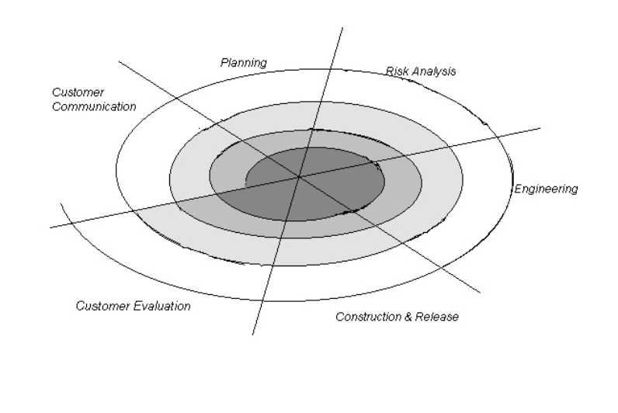

**VU Process Model:**

We follow vu process model from our project because it is better for error testing and removing. VU process model is mixture of spiral and waterfall model diagram of the VU process model as shown below.

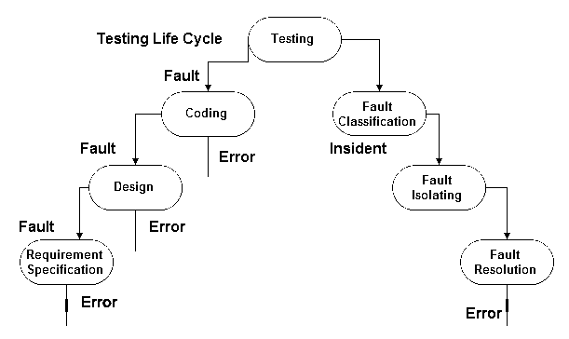

**Work Plan:**

